DRAFT
FOR PUBLIC CONSULTATIONS (12.12.25 TO 11.01.26)
MINISTRY OF PORTS, SHIPPING AND WATERWAYS
NOTIFICATION
New Delhi, the____________ 2026
G.S.R. ______ - In exercise of the powers conferred by sub-section (1) of section 44, clause (h) of sub-section (2) of section 44, sub-sections (1) and (2) of section 116, sub-section (1) of section 130, and clauses (a) and (b) of sub-section (2) of section 130, under Part III and Part VI of the Merchant Shipping Act, 2025 (24 of 2025), and in supersession of the Merchant Shipping (Tonnage Measurement of Ships) Rules, 1987, except as respects things done or omitted to be done before such supersession, the Central Government hereby makes the following rules, namely:—
- Short title, commencement, application and exclusions
- These rules may be called the Merchant Shipping (Tonnage Measurement of Ships) Rules, 2026.
- These rules give effect to the International Convention on Tonnage Measurement of Ships, 1969
- These rules shall come into force on the date of their publication in the Official Gazette.
- These rules shall apply to
- every vessel registered or to be registered in India of the following description, namely,
                - new vessel;
                - existing vessel, which undergo alterations, or modifications, which the Administration deems to be of a substantial variation in their existing gross tonnage;
                - existing vessel if the owner thereof so requests in writing; and
                - all other existing vessels, on and after the 18th day of July, 1994, subject to the exclusions specified in Article 4 of the Convention;
- every vessel other than the vessel covered under subrule (a), when such a vessel is in a port or place in the territorial waters of India, or at an offshore location in India, subject to Article 4 of the Convention.
- Nothing in these rules shall apply to any vessel that is excluded under Article 4 of the Convention.
- For the purposes of these rules—
- an International Tonnage Certificate (1969) shall be required for every Indian vessel of 24 metres in length and above engaged on international voyages;
- an Indian Tonnage Certificate shall be issued to—
- Indian vessels not engaged on international voyages, or
- Indian vessels below 24 metres in length, the tonnages of which have been determined under these rules.

- Definitions:

In these rules, unless the context otherwise requires---
- "Act” means the Merchant Shipping Act, (2025) (24 of 2025);
- “Administration” means the Central Government;
- "Crew" means the seafarers and the apprentices;
- "Director-General" means the Director-General of Maritime Administration appointed under the Act;
- "existing vessel" means a vessel which is not a new vessel;
- "gross tonnage" means the measure of the overall size of the vessel determined in accordance with First Schedule;
- “International Convention on Tonnage Measurement of Ships, 1969” (hereinafter referred to as “the Convention”) means the Final Act of the International Conference on Tonnage Measurement of Ships, 1969, done at London on the 23rd day of June, 1969, as amended from time to time and adopted by way of ambulatory reference;
- "net tonnage" means the measure of the useful capacity of vessel determined in accordance with First Schedule.
- "new vessel" means a vessel the keel of which is laid, or which is at a similar stage of construction, on or after the date specified in Article 3 of the Convention ;
- "passenger" means every person other than--
(i) the master and the members of the crew or other persons employed or engaged in any capacity on board a vessel on the business of that vessel; and
(ii) a child under one year of age;
- "Surveyor" means a surveyor appointed under section 9 of the Act, and includes any person or body of persons authorised by the Central Government by notification issued under that section to exercise the functions of a surveyor under these rules;
- "weathertight" means that in any sea condition water will not penetrate into the vessel, and
- “length”, “breadth” and “moulded depth” shall have the meanings respectively assigned to them in the First Schedule;

Words and expressions used in these rules but not defined herein shall have the meanings respectively assigned to them in the Act and, where applicable, in the Convention and in any Codes or instruments made thereunder.

- Determination of Tonnages:

The gross tonnage and the net tonnage of every vessel to which these rules apply shall be determined in accordance with the provisions of the First Schedule.

Such determination shall be carried out by—
- a Surveyor;
- any person or body of persons authorised by the Central Government, by notification issued under section 9 of the Act, to exercise the functions of a surveyor for the purposes of these rules

The Administration shall remain responsible for every determination of tonnage carried out under this rule..
- Remeasurement of tonnage :

Where the tonnage of a vessel has been, or is deemed to have been, determined under these rules, such tonnage shall remain in force unless—
- any alteration is made in the form, construction, arrangement, capacity, or use of spaces of the vessel that would affect the gross tonnage or net tonnage; or
- it is discovered that the tonnage was erroneously computed.

In any case referred to in sub-rule (1), the vessel shall be remeasured, and its tonnage determined afresh in accordance with Rule 3 and the First Schedule.

Upon remeasurement, the Surveyor shall record the revised tonnage and the Administration shall issue a revised certificate, as applicable.
- Issue of Certificate :

An International Tonnage Certificate (1969) shall be issued to every Indian vessel of 24 metres in length and above engaged on international voyages, the gross tonnage and net tonnage of which have been determined in accordance with these rules.

The certificate shall be in the form set out in the Second Schedule.

An Indian Tonnage Certificate shall be issued to every Indian vessel not engaged on international voyages, the tonnages of which have been determined in accordance with these rules. The certificate shall be in the form set out in the Third Schedule.

Every certificate under this rule shall be issued by the Administration, or by a Surveyor, or by any person or body authorised by the Administration under section 9 of the Act to perform such functions.

The Administration shall remain responsible for all certificates issued under these rules, irrespective of the person or organisation that carries out the determination or signs the certificate.
- Tonnage ascertained in foreign countries

(1) Where the tonnage of a vessel has been ascertained in accordance with the rules in force in a state that is a Contracting government to the Convention, or in accordance with the rules which are substantially similar to these rules, the Administration may accept the tonnage specified in the certificate of registry issued by that state in the same manner, to the same extent and for the same purpose as the tonnage indicated in the certificate of registry issued under these rules.

(2) Notwithstanding sub-rule (1), where the Administration is of the opinion that the tonnage of a foreign vessel, as ascertained by the rules of the State whose flag the vessel is entitled to fly, differs materially from the tonnage that would result from measurement under these rules, the Administration may direct that the vessel be remeasured and that its tonnage be determined in accordance with these rules.
- Cancellation of certificate and validity of certificate

(1) A Tonnage Certificate issued under these rules shall cease to be valid and shall be cancelled by the Administration if alterations have taken place in the arrangement, construction, capacity, use of spaces, total number of passengers the vessel is permitted to carry as indicated in the vessel’s certificates, assigned load line or permitted draught of the vessel, such as would necessitate an increase in gross tonnage or net tonnage.

(2) A certificate issued to a vessel under these rules shall cease to be valid upon transfer of such a vessel from the Indian flag, except as provided in subrule (3)

(3) Upon transfer of an Indian vessel to the flag of another State the Government of which is a Contracting Government to the Convention, the Tonnage Certificate issued under these rules shall remain in force for a period not exceeding three months, or until that State issues another International Tonnage Certificate (1969) to replace it, whichever is the earlier. The Administration shall transmit to that State as soon as possible after the transfer takes place a copy of the certificate carried by the vessel at the time of transfer and a copy of the relevant tonnage calculations, when so requested.

(4) Upon transfer of a vessel to Indian flag from the flag of another State the Government of which is a Contracting Government to the Convention, the Tonnage Certificate of the vessel issued by that State shall remain in force for a period not exceeding three months, or until the Administration issues another Tonnage Certificate to replace it, whichever is earlier. The Administration may request the previous flag Administration, a copy of the certificate carried by the vessel at the time of transfer and a copy of the relevant tonnage calculations.

- Inspection

(1) A vessel flying the flag of a State that is a Contracting Government to the Convention, when such vessel is within India, including coastal waters, shall be subject to inspection by officers duly authorised by the Administration for the purpose of verifying—

(a) That the vessel is provided with a valid International Tonnage Certificate (1969); and

(b) That the main characteristics of the vessel correspond to the data given in the certificate. In no case shall the exercise of such inspection cause any delay to the vessel.

(2) Should the inspection reveal that the main characteristics of the vessel differ from those entered on the Tonnage Certificate so as to lead to an increase in the gross tonnage or the net tonnage, the Government of the State whose flag the vessel is flying shall be informed without delay.

- Suez Canal and Panama Canal Tonnage Certificate:

Where a request is received from the owner of a vessel for the measurement of that vessel for the purpose of the issue of a Suez Canal Tonnage Certificate or a Panama Canal Tonnage Certificate, the vessel may be remeasured by a Surveyor or by any person or body of persons duly authorised by the Administration, and its tonnage determined in accordance with the rules and requirements issued by the Suez Canal Authority or the Panama Canal Authority, as the case may be.
- Fees :

Fees shall be levied under rules at the rates and for the purposes specified in Fourth Schedule.

First Schedule: Determination of Gross and Net Tonnages

Second Schedule: International Tonnage certificate

Third Schedule: Indian Tonnage certificate

Fourth Schedule: Fees

FIRST SCHEDULE
Determination of Gross and Net Tonnages

Definitions.—For the purposes of this Schedule, unless the context otherwise requires—

- "breadth" means the maximum breadth of the ship, measured amidships to the moulded frame line in a ship with a metal shell, and to the outer surface of the hull in a vessel with a shell of any other material;

- "break" means the space above the line of upper deck when the deck is cut off and continue at a higher elevation;

- "cargo space" means enclosed spaces appropriated for the carriage of cargo that are included in the computation of gross tonnage, and which are certified by the Surveyor and permanently marked with the letters “CC”, each letter being not less than 100 millimetres in height and positioned where readily visible;

- "enclosed space" are all those spaces which are bounded by the ship's hull, by fixed or portable partitions or bulkheads, by decks or coverings other than permanent or movable awnings. No break in a deck, nor any opening in the ship's hull, in a deck or in a covering of a space, or in the partitions or bulkheads of a space, nor the absence of a partition or bulkhead, shall preclude a space from being included in the enclosed spac.

- "excluded space" means space of the following description, namely--
(a)(i) space within an erection opposite an end opening extending from deck to deck except for a curtain plate of a depth not exceeding by more than 25 milimeteres the depth of the adjoining beams, such opening having a breadth equal to or greater than 90 per cent of the breadth of the deck at the line of opening of the space. This provision shall be applied so as to exclude from the enclosed spaces only the space between the actual and opening and a line drawn parallel to the line or face of the opening at a distance from the opening equal to one half of the width of the deck at the line of the opening (see figure 1 in APPENDIX I) ;
(ii) should the width of the space because of any arrangement (except by convergence of the outside plating) become less than 90 per cent of the breadth of the deck, only the space between the line of the opening and a parallel line drawn through the point where the athwart ship width of the space becomes equal to, or less than 90 per cent of the breadth of the deck, shall be excluded from the volume of enclosed spaces (see figure 2,3 and 4 in APPENDIX I) ;
(iii) where an interval which is completely open except bulwarks or open rails separates any two spaces, the exclusion of one or both of which is permitted under sub-clauses (a) (i) and/or (a)(ii), such exclusion shall not apply if the separation between the two spaces is less than least half breadth of the deck in way of the separation (see figure 5 and 6 in APPENDIX I) ;
(b) a space under an overhead deck covering open to the sea and weather, having no other connection on the exposed sides with the body of the ship than the stanchions necessary for its support. In such a space open rails or bulwark and curtain plate may be fitted or stanchions fitted at the ship's side, provided that the distance between the top of the rails or the bulwark and the curtain plate is not less than 0.75 metres or one-third of the height of the space, whichever is the greater (see figure 7 in APPENDIX I) ;
(c) a space in a side to side erection directly in way of opposite side openings not less in height than 0.75 metres or one-third of the height of the erection, whichever is greater. If the opening in such an erection is provided one side only, the space to be excluded from the volume of enclosed space shall be limited inboard from the opening to a maximum of one-half of the breadth of the deck in way of the opening (see figure 8 in APPENDIX I);
(d) a space in an erection immediately below an uncovered opening in the deck overhead, provided that such an opening is exposed to the weather and the space excluded from enclosed spaces is limited to the area of the opening (see figure 9 in APPENDIX I) ;
(e) a recess in the boundary of an erection which is exposed to the weather and the opening of which extends from deck to deck without means of closing, provided that the interior width is not greater than the width at the entrance and its extension into the erection is not greater than twice the width of its entrance (see figure 10 in APPENDIX I) ;and such spaces shall not be included in the volume of enclosed spaces except that any such space which fulfils at least one of the following three conditions shall be treated as an enclosed space :-
(i) the space is fitted with shelves or other means for securing cargo or stores;

(ii) the openings are fitted with any means of closure;

(iii) the construction provides any possibility of such opening being closed.
(f) "length" means 96 per cent of the total length on a waterline at 85 per cent of the least moulded depth measured from the top of the keel, or the length from the fore-side of the stem to the axis of the rudder stock on that waterline, if that be greater. In ships designed with a rake of keel the waterline on which this length is measured shall be parallel to the designed waterline;
(g) "moulded depth" means:-
- the vertical distance measured from the top of the keel to the underside of the upper deck at side. In wood and composite ships the distance is measured from the lower edge of the keel rabbet. Where the form at the lower part of the midship section is of a hollow character, or where thick garboards are fitted, the distance is measured from the point where the line of the flat of the bottom continue inwards cuts the side of the keel.

- in ships having rounded gunwales, the depth measured to the point of intersection of the moulded lines of the deck and side shell plating, the lines extending as though the gunwales were of angular design (see figure 11 in APPENDIX I) ;

- in ships where the upper deck is stepped and the raised part of the deck extends over the point at which the depth is to be determined, the depth measured to a line of reference extending from the lower part of the deck along a line parallel with the raised part;
(h) "Upper deck" means the uppermost complete deck exposed to sea and weather fitted as an integral part of the ship's structure being a deck all openings in weather, portions of which are fitted with permanent means of weathertight closing arrangements and below which openings in the sides of the ships are fitted with permanent means of watertight closing and in a ship having a stepped upper deck, the lowest line of the exposed deck and continuation of that line parallel to the upper part of the deck shall be taken as the upper deck. Provided that steps with length of not more than 2.4 metres of which do not extend over the full breadth of the ship may not be taken into account when determining the line of upper deck.

Gross Tonnage :The gross tonnage (GT) of a ship shall be determined by the following formula :
GT = K₁V
where V= Total volume of all enclosed spaces of the ship in cubic metres.
K1=0.2+0.02logV (or as tabulated in Appendix II).

Provided that in the case of Indian ships of less than 24 metres in length, the gross tonnage (GT) may be determined by the following formula:
GT = 0.23 LBD , where
L = length as defined in clause (f) of paragraph 1.
B = breadth as defined in clause (a) of paragraph 1.
D = moulded depth as defined in clause (g) of paragraph 1.

Net Tonnage :

(1) The net tonnage (NT) of a ship shall be determined by the following formula :
NT = K₂Vc [4D/3D]² + K₃ (N₁ + N₂/10), in which formula :-
- the factor [4D/3D]² shall not be taken as greater than unity;
the term K₂V_{c} [4D/3D]² shall not be taken as less than 0.25 GT ; and
NT shall not be taken as less than 0.30 GT, and in which V_{c} = total volume of cargo spaces in cubic metres.
K2 = 0.2 + 0.02 log10Vc (or as tabulated in Appendix II.)
D = moulded depth amidships in metres as defined in clause (g) of paragraph 1
d = moulded draught amidships in metres as defined in sub-paragraph(2).
K3 = 1.25 GT + 10,000 / 10,000
N1 = Number of passengers in cabins with not more than 8 berths,
N2 = Number of other passengers,
N1 + N2 = total number of passengers the ship is permitted to carry as indicated in the ship's passenger certificate, when N1 + N2 is less than 13, N1 and N2 shall betaken as zero,

GT = Gross tonnage of the ship as determined in accordance with the provisions of rule

Provided that in respect of Indian ships of less than 24 metres in length, the net tonnage (NT) may be determined by the following Formula:
NT = 0.20 LBD, where
L = aggregate length of cargo spaces from bulk head to bulk head
B = breadth as defined in clause (a) of paragraph 1.
D = moulded depth as defined in clause (g) of paragraph 1.
provided further that NT shall not be less than 0.30 GT.
(2) The moulded draught referred to in sub-paragraph(1) is equal to moulded draught amidships in metres derived as follows:
(i) for ships to which load line rules apply, the draught corresponding to the summer load line (other than timber load lines) assigned in accordance with those rules;
(ii) for passenger ships, the draught corresponding to the deepest sub division load line assigned in accordance with the Merchant Shipping (Construction and Survey of Passenger Ships) Rules,;
(iii) for ships not assigned load lines in accordance with load line rules the maximum permitted draught or 75% of moulded depth amidship, as the case may be.

Calculations of volumes :
(1) All volumes included in the calculation of gross and net tonnage shall be measured, irrespective of the fitting of insulation or the like, to the inner side of the shell or structural boundary plating in ships constructed of metal, and to the outer surface of the shell or to the inner side of structural boundary surface in ships constructed of any other material.
(2) Volumes of appendages shall be included in the total volume. Spaces used both for ballast and cargo should be included as cargo spaces.
(3) Volumes of spaces open to the sea may be excluded from the total volume.
(4) In accessible masts, king posts, air trunks and similar erections outside of and separated on all their sides from enclosed spaces and having cross sectional areas not exceeding one square metre should not be measured. similarly, independent enclosed spaces of a volume not exceeding one cubic metre shall not be measured.
(Note: Volume of spaces under pontoon hatch cover shall be included in the enclosed volume. The volume of spaces under such hatch cover underside of which are open are to be included in the Volume of cargo space also.)

Measurement and calculations :
(1) All measurement used in the calculation of volumes shall be to the nearest centimetre. Final tonnage figures obtained in accordance with paragraphs3 and 4 shall be rounded off to the nearest unit without decimals.
(2) The underdeck volume shall be calculated by methods providing accuracy acceptable to the Administration. However, the methods to be adopted will be one or a combination of the following methods :-
(i) Suitable computer programme, or

(ii) Manual integration of cross sectional areas of the hull at transverse sections obtained by following divisions of the length of upperdeck :

After extremity to After Perpendicular | Two equal intervals
Forward 20% and After 20% of the length between the After and Forward Perpendiculars | Four equal intervals
Centre 60% of the length between After and Forward Perpendiculars | Six equal intervals
Forward Perpendicular to Forward most extremity | Two equal intervals

These cross sectional areas may be obtained by using planimeter or from the “Section Area Curves” or the “Bonjean’s Curves” or by the manual integration method or measurement of the transverse section given in Appendix III or

(iii) By physical measurement in accordance with Appendix III.

Change of net tonnage :
(1) When the characteristics of a ship, such as V, V_{c} , d, N₁ or N₂ as determined in accordance with paragraphs3 and 4 are altered and where such an alteration results in an increase in its net tonnage as determined in accordance with the provisions of paragraph4, the net tonnage of the ship corresponding to the new characteristics shall be determined and shall be applied without delay.
(2) A ship to which load lines referred to in sub-para4(2)(i) and 4(2)(ii) are concurrently assigned shall be given only one net tonnage as determined in accordance with the provisions of paragraph4 and that tonnage shall be the tonnage applicable to the appropriate assigned load line for the trade in which the ship is engaged.
(3) When the characteristics of a ship such as V, V_{c} , d, N₁ or N₂ as defined in paragraphs3 and 4 are altered or when the appropriate assigned load line referred to in sub-para(2) is altered due to the change of the trade in which the ship is engaged and where such an alteration results in a decrease in its net tonnage as determined in accordance with para4, a new International tonnage Certificate (1969) incorporating the net tonnage so determined shall not be issued until twelve months have elapsed from the date on which the current certificate was issued:
Provided that this requirement shall not apply,-
- if the ship is transferred to the flag of another State, or

- if the ship undergoes alterations or modifications which are deemed by the Administration to be of major character, such as the removal of a superstructure which requires an alteration of the assigned load line, or

- to passenger ships which are employed in the carriage of large numbers of special trade passengers.

Deck cargo and cargo in other spaces :
(1) If any ship other than a ship exclusively engaged in trading between any port or place in India carries any deck cargo or cargo in spaces not included in the computation of net tonnage, the tonnage of space so utilized for carrying cargo shall be measured in the manner specified in Appendix IVand added to the relevant tonnage of the ship and the levy of dues based on ship's tonnage.
(2) The tonnage of spaces referred to in sub-rule (1) shall be ascertained by a surveyor or by an officer of the customs referred to in section 3 of the Customs Act, 1962, in the manner directed in Appendix IV and when so ascertained shall be entered by him in ship's official log book and also in a memorandum which he shall deliver to the Master and the Master shall, when any dues are demanded on ship's tonnage produce that Memorandum in the like manner as if it were ship's Certificate of Registry or in the case of a ship other than an Indian ship, a document equivalent to a Certificate of Registry.
.

APPENDIX I
[ See paragraph 1(e) of First Schedule ]

Figures referred to inPara1(e)

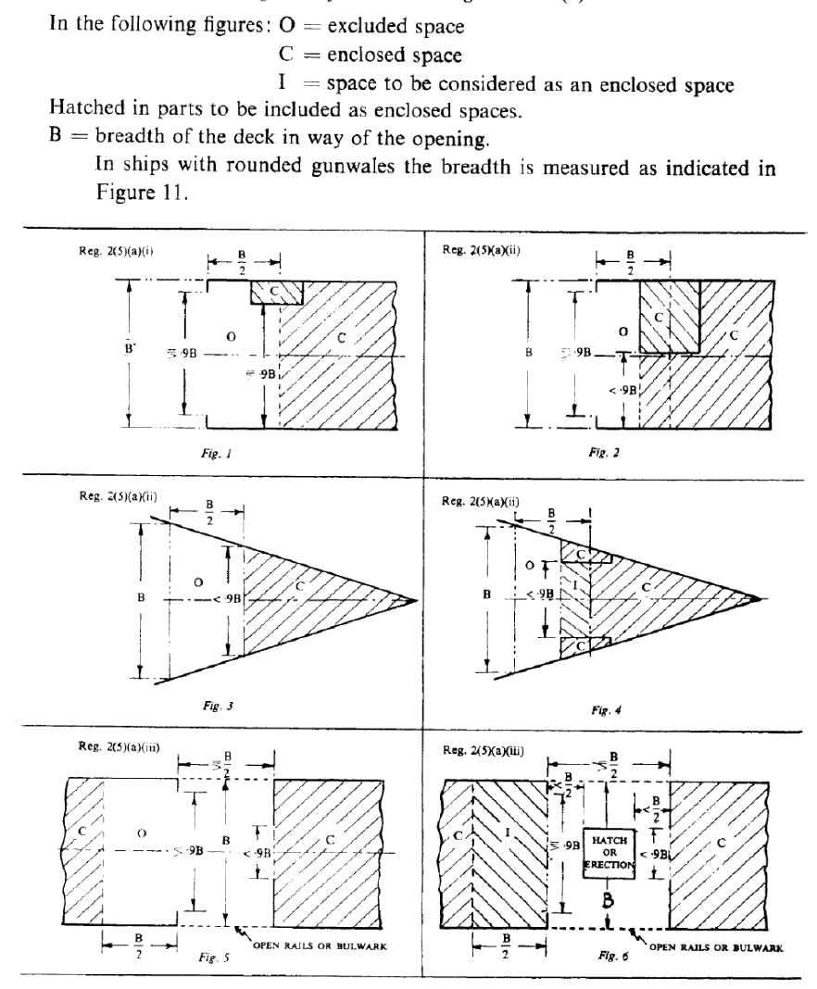

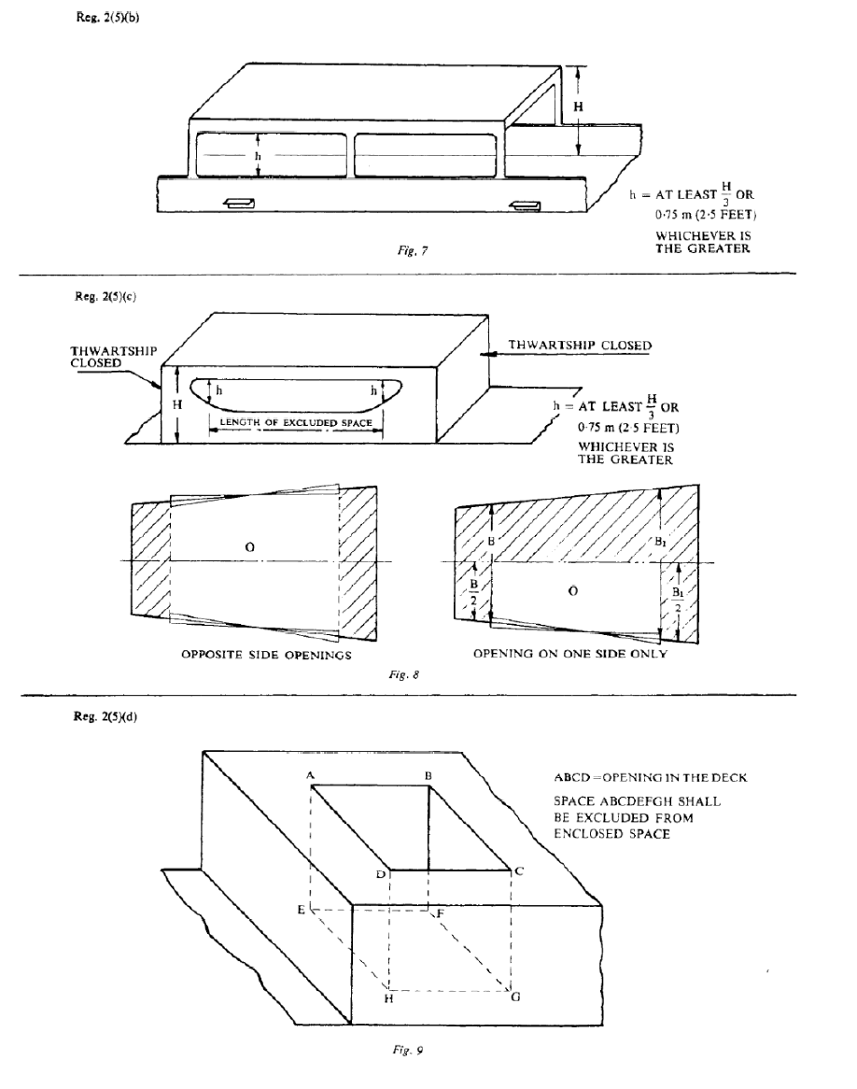

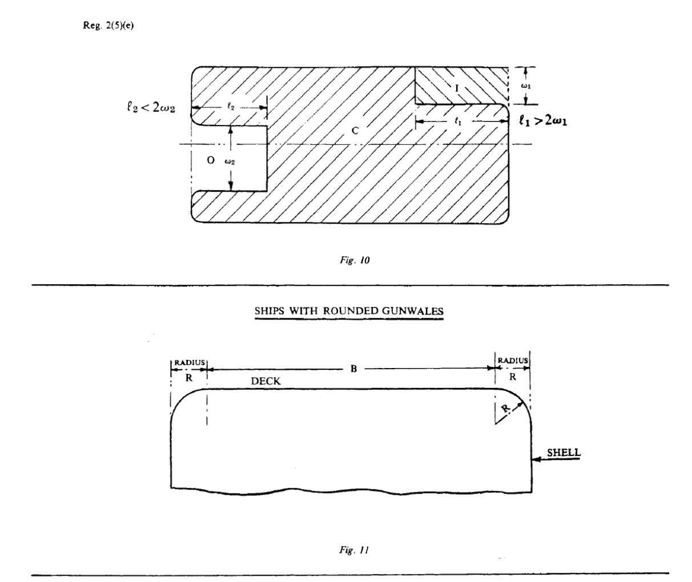

APPENDIX II [ See First Schedule, paragraphs 2 and 3]
COEFFICIENTS K1 AND K2 REFERRED TO IN RULES 2 and 3
V OR V_{C} = Volume in cubic metres
V or V_{C} | K₁ or K₂ | V or V_{C} | K₁ or K₂ | V or V_{C} | K₁ or K₂ | V or V_{C} | K₁ or K₂
10 | 0.2200 | 45000 | 0.2931 | 330000 | 0.3104 | 670000 | 0.3165
20 | 0.2260 | 50000 | 0.2940 | 340000 | 0.3106 | 680000 | 0.3166
30 | 0.2295 | 55000 | 0.2948 | 350000 | 0.3109 | 690000 | 0.3168
40 | 0.2320 | 60000 | 0.2956 | 360000 | 0.3111 | 700000 | 0.316
50 | 0.2340 | 65000 | 0.2963 | 370000 | 0.3114 | 710000 | 0.3179
60 | 0.2356 | 70000 | 0.2969 | 380000 | 0.3116 | 720000 | 0.3170
70 | 0.2369 | 75000 | 0.2975 | 380000 | 0.3118 | 730000 | 0.3171
80 | 0.2381 | 80000 | 0.2981 | 390000 | 0.3120 | 740000 | 0.3173
90 | 0.2391 | 85000 | 0.2986 | 400000 | 0.3123 | 750000 | 0.3174
100 | 0.2400 | 90000 | 0.2991 | 410000 | 0.3125 | 760000 | 0.3175
200 | 0.2460 | 95000 | 0.2996 | 420000 | 0.3127 | 770000 | 0.3176
300 | 0.2495 | 100000 | 0.3000 | 430000 | 0.3129 | 780000 | 0.3177
400 | 0.2520 | 110000 | 0.3008 | 440000 | 0.3131 | 790000 | 0.3188
500 | 0.2540 | 120000 | 0.3016 | 450000 | 0.3133 | 800000 | 0.3180
600 | 0.2556 | 130000 | 0.3023 | 460000 | 0.3134 | 810000 | 0.3181
700 | 0.2569 | 140000 | 0.3029 | 470000 | 0.3136 | 820000 | 0.3182
800 | 0.2581 | 150000 | 0.3035 | 480000 | 0.3138 | 830000 | 0.3183
900 | 0.2591 | 160000 | 0.3041 | 490000 | 0.3140 | 840000 | 0.3184
1000 | 0.2600 | 170000 | 0.3046 | 500000 | 0.3142 | 850000 | 0.3185
2000 | 0.2660 | 180000 | 0.3051 | 510000 | 0.3143 | 860000 | 0.3186
3000 | 0.2695 | 190000 | 0.3056 | 520000 | 0.3145 | 870000 | 0.3187
4000 | 0.2720 | 200000 | 0.3060 | 530000 | 0.3146 | 880000 | 0.3188
5000 | 0.2740 | 210000 | 0.3064 | 540000 | 0.3148 | 890000 | 0.3199
6000 | 0.2756 | 220000 | 0.3068 | 550000 | 0.3150 | 900000 | 0.3190
7000 | 0.2769 | 230000 | 0.3072 | 560000 | 0.3151 | 910000 | 0.3191
8000 | 0.2781 | 240000 | 0.3076 | 570000 | 0.3153 | 920000 | 0.3192
9000 | 0.2791 | 250000 | 0.3080 | 580000 | 0.3154 | 930000 | 0.3193
10000 | 0.2800 | 260000 | 0.3083 | 590000 | 0.3156 | 940000 | 0.3194
15000 | 0.2835 | 270000 | 0.3086 | 600000 | 0.3157 | 950000 | 0.3195
20000 | 0.2860 | 280000 | 0.3089 | 610000 | 0.3158 | 960000 | 0.3196
25000 | 0.2880 | 290000 | 0.3092 | 620000 | 0.3160 | 970000 | 0.3197
30000 | 0.2895 | 300000 | 0.3095 | 630000 | 0.3161 | 980000 | 0.3198
35000 | 0.2909 | 310000 | 0.3098 | 640000 | 0.3163 | 990000 | 0.3199
40000 | 0.2920 | 320000 | 0.3101 | 650000 | 0.3164 | 1000000 | 0.3200
Coefficients K₁ or K₂ at intermediate values of V or V_{c} shall be obtained by linear interpolation.

APPENDIX III
Measurement and Calculations
[ See paragraph 6 of First Schedule ]
1. Calculations of Volume :
- The length of the upper deck shall be measured in a straight line in the middle plane of the ship between the points at the forward and after ends of the deck where the underside of the deck or line of continuation thereof in way of breaks or discontinuous of the deck meets the inner side of the shell in ships constructed of metal or meets the outer surface of the hull in ships constructed of any other material. such length shall be referred to as the "tonnage length".

- The volume under the upper deck to be measured in three parts where the length of the foremost and aftermost parts shall be taken as twenty five per cent of the tonnage length, T_{L}.

- Each of the three parts of the Tonnage Length shall be divided into equal parts as shown in the following table (see Fig. 1):

Tonnage Length T_{L}  in metres | Forward 25% T_{L} and after 25% T_{L} | Centre 50% T_{L}
<60 | 4 | 4
>60 ≤ 120 | 6 | 6
> 120 | 8 | 8

- The Tonnage Depth of a transverse section shall be the distance from the underside of the Tonnage Deck at centerline to the upper side of the keel or bottom plating in ships built of metal, to the underside of the keel rabbet in ships built of wood and to the outside of the hull in ships built of other material corrected by deducting one-third of the round of beam in the case of ships where the tonnage deck is of parabolic form or in other cases an equivalent deduction based on equal areas.

- The Tonnage Depth as defined in (d) and taken at amidships of the total tonnage length T_{L} shall be divided into-
  - 5 equal parts where the depth is 6 metres or less;
  - 7 equal parts where the depth exceeds 6 metres but is less than 12 metres and;
  - 9 equal parts where the depth exceeds 12 metres.

- The bottom part of each transverse section shall be further subdivided into 4 equal parts (see Fig.2).

- The volume of each separate cargo space in a hold or superstructure bounded by deck, shell, longitudinal and/or transverse bulkheads as the case may be, shall be measured separately and generally in accordance with the method of measurement of the underdeck.

- The space below the top of floor line of cargo ships with single bottoms to be included in the measurement of the cargo space irrespective of whether there is any ceiling fitted on top of the open floors.

- Superstructures such as Poop, Bridge or Forecastle shall be measured generally in accordance with the method of measurement of the underdeck.
2. Appendages such as a bulbous bow, unusual shaped stem, stern and shaft bossing shall be measured separately as an appendage by any practical method acceptable to the Administration and the volume added to the underdeck volume.
3. Spaces open to the sea and located below the load water line such as bow thruster nits, rudder trunks and stabilizer fin openings etc. and spaces open to the sea and weather above the load waterline such as hawse and chain pipes shall be measured and excluded from the gross tonnage and also the net tonnage where applicable.
4. In computation of areas and volumes, Simpson's first rule shall be used except for areas and volumes of geometrically defined spaces which shall be calculated with application of standard geometric formula.

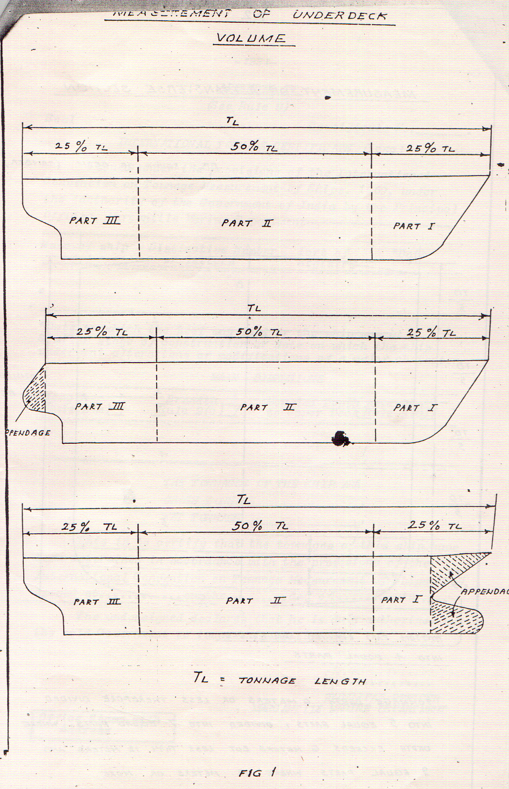
Fig 1 : Measurement of Underdeck Volume

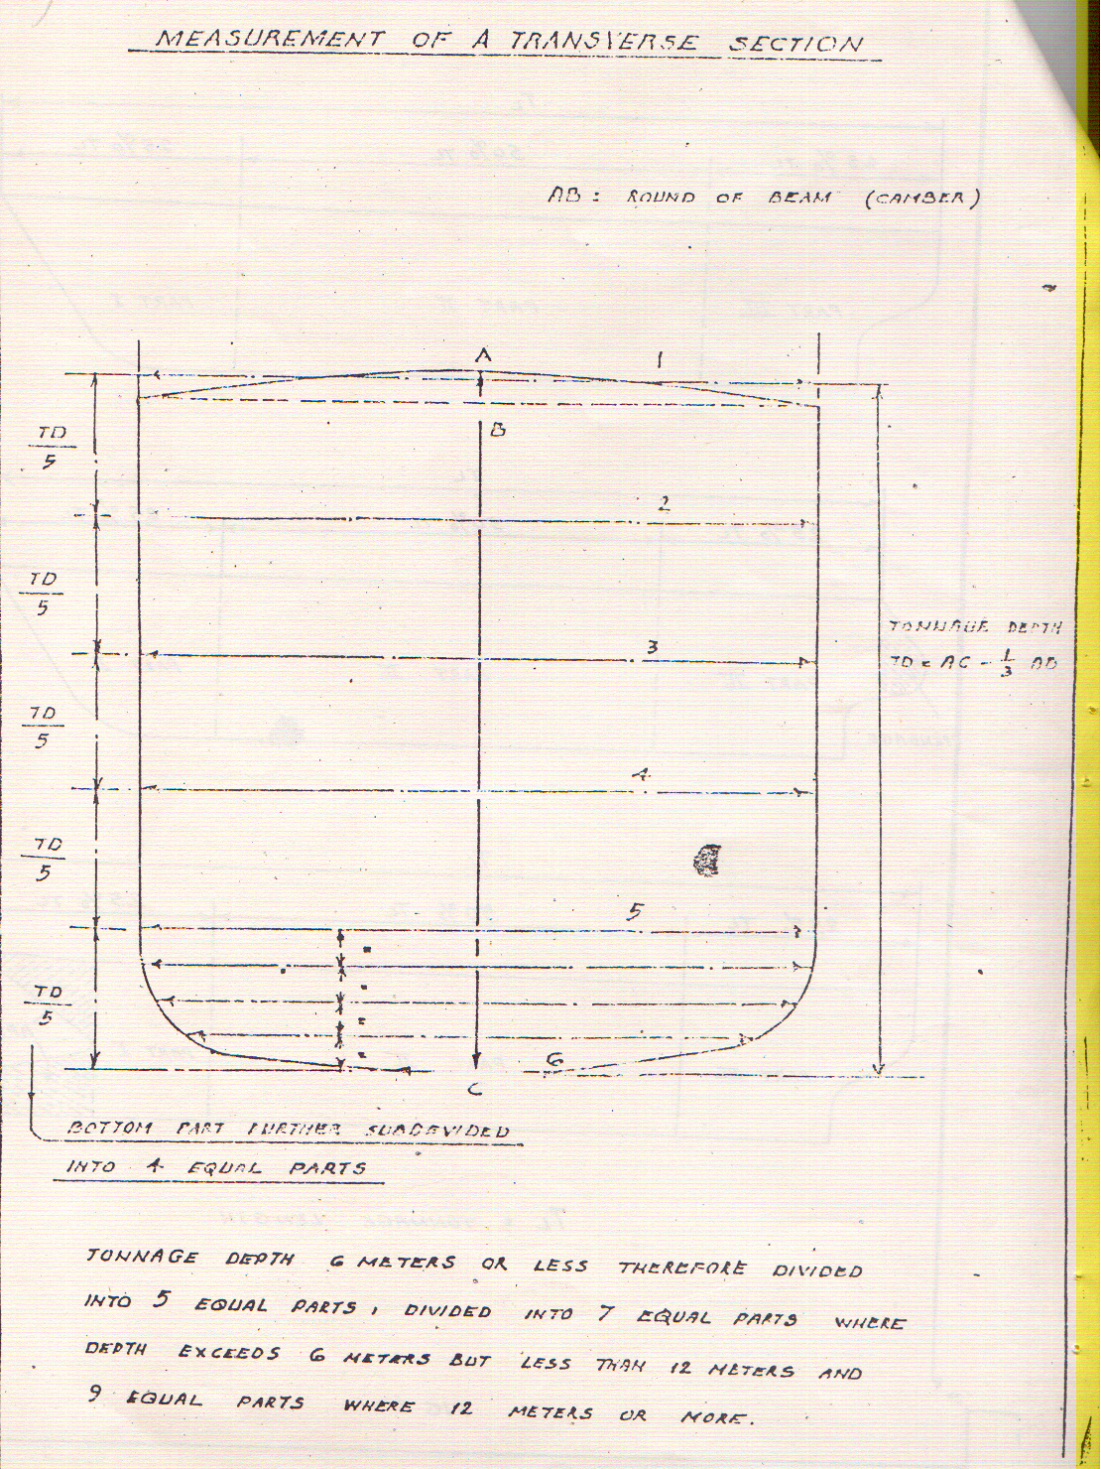
Fig 2: Measurement of transverse section

APPENDIX – IV
[ See paragraph10 of First Schedule ]

- The cubic capacity of covered or uncovered spaces upon deck or excluded spaces which have not been included in the computation of gross tonnage when used for carriage of cargoes, shall be determined by multiplying the area in square metres of spaces occupied by cargo, as determined in accordance with the provisions of Appendix III by the maximum height of goods in metres. The cubic capacity so arrived shall be divided by 2.83 for determining tonnage of such spaces.
- The cubic capacity of any space or spaces in the ships which have been included in the computation of gross tonnage but not in the computation of net tonnage, when used for carriage of cargoes shall be determined by calculating the volume of the whole space in which the cargo is carried. The cubic capacity of the space determined in accordance with the provisions of Appendix III shall be divided by 2.83 for determining tonnage of such spaces.

Second Schedule
( See Rule 5(1))
Seal Certificate No.___
INTERNATIONAL TONNAGE CERTIFICATE (1969)
Issued under the provisions of the International Convention on Tonnage Measurement of Ships, 1969, under the authority of the Government of India by -----------------------------
Name of Ship | Distinctive Number or letters | Port of Registry | *Date
*Date on which the keel was laid or the ship was at a similar stage of construction or date on which the ship underwent alterations or modifications of a major character.
MAIN DIMENSION
Length  [Article 2(8)] | Breadth  [Regulation 2(3)] | Moulded Depth amidship to Upper Deck [Regulation 2(2)]
THE TONNAGES OF THE SHIP ARE
GROSS TONNAGE___________________________.
NET TONNAGE______________________________.
This is to certify that the tonnage of this ship have been determined in accordance with the provisions of the International Convention on Tonnage Measurement of Ships, 1969. Issued at ………………… on the ………………. day of …………….. 19………….
The undersigned declares that he is duly authorized by the said Government to issue this Certificate.

…………………….
Office Stamp with Address

PRINCIPAL OFFICER
MERCANTILE MARINE DEPARTMENT

SPACES INCLUDED IN TONNAGE
GROSS TONNAGE |  |  | NET TONNAGE
Name of Space | Location | Length | Name of Space | Location | Length

______________________________________
NUMBER OF PASSENGERS
No. of Passengers in cabins with not more than 8 berths:_________________
No. of other Passengers :___________
____________________________________________________________________________________
EXCLUDED SPACES MOULDED DRAUGHT __________________
[Regulation 2(4)] [Regulation 2(2)]

*An asterick should be added to those spaces
which comprises both enclosed and excluded
spaces
____________________________________________________________
Date and place of original measurement
_____________________________________________________________
Date and place of last previous measurement.
_____________________________________________________________
REMARKS :
Note:- Length, breadth and moulded depth are defined in the International Convention on Tonnage Measurement of Ships, 1969 as follows: Length — Article 2(8); Breadth — Regulation 2(3); Moulded depth — Regulation 2(2). For domestic application see First Schedule, paragraph 1(f) (length), paragraph 1(a) (breadth) and paragraph 1(g) (moulded depth) of the Merchant Shipping (Tonnage Measurement of Ships) Rules, 2026. Moulded draught used for net tonnage calculations is set out in Regulation 2(2) of ITC-69 and in First Schedule, paragraph 3(2).

Third Schedule
INDIAN TONNAGE CERTIFICATE
Issued under the provisions of the Merchant Shipping (Tonnage Measurement of Ships) Rules, 2026 (See Rule 5(1))
Name of ship | Off. No. | Port of Registry | Date when keel laid / Alteration completed/ Remeasured*/
*State whether keel laid or alteration completed or remeasured.
Length Rule 1(f) | Breadth Rule 1(a) | Moulded depth amidship  Rule 1(g)

GROSS TONNAGE __________________________
NET TONNAGE __________________________
This is to certify that the tonnages of this ship have been determined in accordance with the provisions of the Merchant Shipping (Tonnage Measurement of Ships) Rules, 2026..

Issued at…………….. Date……..

_________________
Principal officer
Mercantile Marine Department
SPACES INCLUDED IN TONNAGE

GROSS TONNAGE |  |  | NET TONNAGE
Name of Space | Location | Length | Name of Space | Location | Length

______________________________________
NUMBER OF PASSENGERS
No. of Passengers in cabins with not more than 8 berths:_________________
No. of other Passengers :___________

EXCLUDED SPACES MOULDED DRAUGHT __________________
[Rule 1(e)] [Rule 3(2)]

*An asterick should be added to those spaces
which comprises both enclosed and excluded
spaces
____________________________________________________________
Date and place of original measurement
_____________________________________________________________
Date and place of last previous measurement.
_____________________________________________________________

REMARKS :
Note:- Length, breadth and moulded depth are defined in the International Convention on Tonnage Measurement of Ships, 1969 as follows: Length — Article 2(8); Breadth — Regulation 2(3); Moulded depth — Regulation 2(2). For domestic application see First Schedule, paragraph 1(f) (length), paragraph 1(a) (breadth) and paragraph 1(g) (moulded depth) of the Merchant Shipping (Tonnage Measurement of Ships) Rules, 2026. Moulded draught used for net tonnage calculations is set out in Regulation 2(2) of ITC-69 and in First Schedule, paragraph 3(2).

FOURTH SCHEDULE(See Rule 10)

(a) | Measurement for issue of International Tonnage Certificate (1969) or Indian Tonnage Certificate.
(i) | First measurement of an Indian ship or a foreign ship; Re-measurement, including under deck Tonnage volume :
 | Ships less than 24mtrs. in length | Rs.3000/-
 | Ships 24mtrs. in length & above | Rs.20000/-
 | for each 100 tons or part thereof of the gross tonnage | Rs.250/-
(ii) | Re-measurement not involving under deck tonnage volume.
 | For measurement of each as pace on or above upper deck | Rs.2500/-
 | For measurement for each of the following space, viz.  Appendage  Cargo compartment  Number of and spaces for passengers  Water ballast spaces  Bunker spaces  Stores rooms | Rs.5000/-
(b) | For inspection at the request of owners or by a statutory authority for verification of tonnage and when no re-measurement is required | Rs.2500/-
(c) | For measurement of space occupied by cargo under rule 10. | Rs.2500/- for each space
(d) | Measurement of Suez Canal and Panama Canal Tonnage:
(i) | For first measurement of a ship for Suez Canal or Panama Canal Tonnage Certificate. | The fee in (a)(i) plus three-fifths of that fee
(ii) | For a Suez Canal and a Panama Canal Tonnage Certificate if the measurements are made at the same time. | Two and Quarter times the fee in (a)(i)
(iii) | For re-measurement of a ship following alteration in other than under deck | Fee as in (a)(ii)
(e)  (i) | For issue of International Tonnage Certificate (1969) or Indian Tonnage Certificate | Rs.2500/-
(ii) | For issue of duplicate of International Tonnage Certificate (1969) or Indian Tonnage Certificate. | Rs.2300/-
(iii) | For issue of Suez Canal or Panama Canal Tonnage Certificate | Rs.5000/-
(iv) | For issue of an additional copy of Suez Canal or Panama Canal Tonnage Certificates | Rs.3750/-
(v) | For supply of details of Suez Canal or Panama Canal Tonnage Calculations to the owner. | Rs.5000/-

