MINISTRY OF SHIPPING NOTIFICATION
New Delhi, the xx/xx/xxxx (Date)
G.S.R. xx.—In exercise of the powers conferred by section 319(1) read with section 62(2)(b) of the Merchant Shipping Act, 2025 (24 of 2025) and in supersession of the merchant Shipping (Continuous Discharge Certificate-cum-Seafarers Identity Document) Rules, 2017, except as respects things are done or omitted to be done before such supersession, the Central Government hereby makes the following rules, namely:
- Short title, commencement and application.—(1) These rules may be called the merchant Shipping (Continuous Discharge Certificate) Rules, xxxx.
  - They shall come into force after one hundred and eighty days front the date of their publication in the Official Gazette.
  - They shall apply to Indian citizen, who fulfil the eligibility conditions specified under rule 4 of these rules.
- Definitions.—(1) In these miles, unless the context otherwise requires, -
  - "Act" means the Merchant Shipping Act, 2025 (24 of 2025) ;
  - "Approved training institute" means an Approved Training Institute as defined under clause 8 of rule 4 of the Merchant Shipping (Standards of Training. Certification and Watchkeeping for Seafarers) Rules, xxxx;
  - "Form" means a form appended to these rules;
  - "Principal Officer" means the Principal Officer of a port appointed under sub-section (1) of the Merchant Shipping Act;
  - "Shipping Master" means a shipping master of a port appointed under sub-section (1) of section 12 of the Act or such other officer as may be authorized by the Director General of Shipping.
- Words and expressions used in these rules and not defined but defined in the Act shall have the meanings respectively assigned to them.
- Application for Continuous Discharge Certificate.—(1) A citizen of India who fulfils the eligibility conditions as specified in rule 4 and desirous to obtain a Continuous Discharge Certificate, shall apply to the Shipping Master.
(2) Every such application shall be in Form-1 appended to these rules and in the manner as may be specified by the Director General of Shipping.
- Eligibility for obtaining Continuous Discharge Certificate.—(l) An applicant shall be a citizen of India.
- An applicant shall be medically fit and possess a valid certificate in the form prescribed under Annexure IV and V of the Merchant Shipping (medical Examination) Rules, 2000, to the effect that he is medically fit to be employed on board ships.
- An applicant for issue of Continuous Discharge Certificate must have completed the following basic familiarisation courses in an approved training institute and hold a certificate to that effect, namely:-:-
  - Personal Survival Techniques (PST) or Proficiency in survival craft anal rescue boards (PSCRB).
  - Fire Prevention and Fire Fighting (FPFF) or Advance Fire Fighting (AFF)
  - Elementary First Aid (EFA) or Medical First Aid (MFA) or Medical Care (MC).
  - Personal Safety and Social Responsibility (PSSR).

(5). Security Training for Seafarers with Designated Security Duties (STSDSD) or Ship
Security Officer (SSO).
- An applicant shall not be less than eighteen years of age;
- An applicant must have passed Tenth Standard.
- Fee.—(1)The fee for obtaining the Continuous Discharge Certificate or its reissue or renewal or duplicate shall be seven hundred rupees, which shall be non-refundable, payable to the Shipping Master. (2) The payment of fee may be revised by the Director General of Shipping, however, the fee shall not exceed fifteen hundred rupees. (3) The said payment of fee shail be made by e-payment or as may be specified by the Director-General of Shipping.
- Issue of Continuous Discharge Certificate.—(1) The Shipping Plaster shall, after the descriptive Particulars of the applicant have been entered in and the photograph affixed to the Continuous Discharge Certificate, affix his signature and official seal and issue the same to the applicant, who fulfils all the eligibility conditions provided under rule 4.
- .A Continuous Discharge Certificate issued under these rules shall be in Form-2 and shall be serially numbered.
- The continuous Discharge Certificate (CDC) shall be dispatched within thirty days from the date of receipt of the application.
- In case of rejection of application, the reasons for rejection of the application shall be intimated to the applicant.
- Register of Continuous Discharge Certificate. —The Shipping Master shall maintain a register of the counter folio or the Continuous Discharge Certificate issued to the seafarers
- Period of Validity.-(l) A Continuous Discharge Certificate issued under these rules shall the valid for a period of ten years’ and may be renewed on expiry or within one year prior to date of expiry, on an application in Form-3 from the holder along with the prescribed fee of rupees seven hundred to the Shipping Master for a further period of ten years at a time, if his Continuous Discharge Certificate has not been cancelled, withdrawn or suspended under these rules.
(2) If the period of validity of Continuous Discharge Certificate of a Seafarer expires during the voyage, it shall continue to be valid till the end of the voyage.
- Cancellation, withdrawal or suspension of a Continuous Discharge Certificate—(1) Where the Director General of Shipping is satisfied that a Seafarer has committed a misconduct of a nature specified in section 97 of the Act or on a report received by hint that a seafarer has deserted his ship in the circumstances specified in section 98(3), or that he has been convicted of as offence of the nature referred to in section 100 of the Act, he may direct to the Shipping Master that Continuous Discharge Certificate of such seafarer shall be cancelled or withdrawn or suspended for such Period as may be specified in the order;
- If a seafarer is guilty of an offence of committing any of the acts mentioned in section 99 of the .bet or is convicted of an offence under any other law for the time being in force, the Director General may direct to the Shipping Master that Continuous Discharge Certificate of such seafarer shall lie cancelled or withdrawn or suspended for .such period as may be specified in the order.
- Where the Director General of Shipping is satisfied that the holder of a Continuous Discharge Certificate granted under these rules, committed a misconduct and or’ endangering life on ship while working on any ship on any flag, he may direct the Shipping Master that Continuous

Discharge Certificate of such seafarer shall be cancelled or withdrawn or suspended tor such period as may be specified in the order.
- If the Shipping Master has reasons to believe that the holder of a Continuous Discharge Certificate granted under these rules has obtained the same by providing false or erroneous information, he shall cancel such Continuous Discharge Certificate forthwith;
- If a person applies for obtaining Continuous Discharge Certificate, with the false or false documents, his application shall be rejected forthwith.
- If any authority under the Act has reason to believe that entries made in the Continuous Discharge Certificate are forged or false entries, then such authority shall with its conclusive findings and proof refer it to the Shipping Master for cancellation of such Continuous Discharge Certificate.
- If it is reported to or detected by the Shipping Master that the entries made in the Continuous Discharge Certificate forged or false, then he shall cancel such Continuous Discharge Certificate forthwith.
(8) If it is reported to or detected by any authority under the Act that the seafarer has obtained false or forged Certificates under the Act, the shipping master shall cancel the Continuous Discharge Certificate.
- A person whose Continuous Discharge Certificate is cancelled under sub-rules (1),(2),(3),(4),(6), f7) and (8) and a person whose application is rejected under sub-rule (5), shall be debarred for applying and obtaining Continuous Discharge Certificate for a period upto five years and shall not be granted Continuous Discharge Certificate during this period;
- Where the Continuous Discharge Certificate has been cancelled or suspended or a person debarred, as above, the reasons for the same shall be intimated in writing to the person to whom it was issued and a copy of the order of such cancellation or suspension or debarment as the case may be, shall be endorsed to all other Shipping h4asters in India and the Director General of Shipping.
- Before cancellation, withdrawing or suspension of the Continuous Discharge Certificate as the case may be, the Continuous Discharge Certificate holder shall be intimated in writing and given an opportunity to represent his case before the Shipping Plaster. The Shipping Master shall also intimate in writing the reasons for cancellation, withdrawing or suspension, as the case may be to the Continuous Discharge Certificate holder.
- If a Continuous Discharge Certificate holder wishes to discontinue the sea service and request for cancellation of his Continuous Discharge Certificate, the same shall be cancelled by the Shipping Master.
- Appeal.—(1) Any applicant aggrieved by any order made under these rules by the Shipping Master, tray, within a period of sixty days of the receipt of such order, prefer an appeal to the jurisdictional Principal Officer, Mercantile Marine Department.
- Any applicant aggrieved by any order made under these rules by the jurisdictional Principal Officer, Mercantile Marine Department, may, within a period of sixty days of receipt of such order, prefer an appeal to the Director General of Shipping.
- No appeal shall be admitted, if it is preferred after the expiry of the period prescribed under sub-rule (1) or (2):
Provided that an appeal may be admitted after the expiry of period, if the appellate authority satisfies
that the appellant had sufficient cause for not preferring the appeal within the prescribed period.

- Record of cancelled Continuous Discharge Certificate, etc.—The Shipping Master shall maintain a register of Continuous Discharge Certificate which has been withheld, cancelled or suspended under rule 9.
- Issuance of Duplicate Continuous Discharge Certificate.—(1) Where a Continuous Discharge Certificate of a person issued under these rules, is mislaid, destroyed, defaced or mutilated or the pages of the Continuous Discharge Certificate are exhausted, such person shall apply to the Shipping Maester in Form-3 alongwith a fee of seven hundred rupees for issuance of a duplicate copy of the Continuous Discharge Certificate;
(2) Where a Continuous Discharge Certificate of a person is lost and where a proper complaint has been made by him with the Police, such person may apply to the Shipping Master concerned in Form-3 along with a copy of the First Information Report (FIR) and fee for issuance of a duplicate copy of Continuous Discharge Certificate;

- Where a Continuous Discharge Certificate issued under these rules is lost at high seas while working on a ship and where an enquiry’ and log entry has been made by the Master’ of the ship in that respect, such person may apply to the Shipping Plaster concerned in Form-3 alongwith such enquiry report and log entries, and fee, for issuance of a duplicate copy of Continuous Discharge Certificate.
- Alteration in the details provided in the Continuous Discharge Certificate.—(1) And request for alteration of the date of birth of a seaman as given in the Continuous Discharge Certificate, shall be allowed to be made by the Shipping Master on production of either certified extract of entries relating to birth front the Municpal or either Register' of Births anal Deaths;
(2) Any request for change of name in the Continuous Discharge Certificate granted under these rules shall be allowed to be made by the Shipping Master on production of a certified copy of Gazette Notification in that respect together with the of seven hundred rupees for issue of duplicate copy of Continuous Discharge Certificate.

I4. Returns of Continuous Discharge Certificate.—The Shipping Master shall, at the beginning of each quarter furnish to the Director General of Shipping a return of the number of Continuous Discharge Certificate issued to seafarers from his port during the previous quarter in Form -4.

FORNI-1
[See sub- rule (2) of rule 3]
Application Form for Continuous Discharge Certificate
- Name of the Candidate
- Father’s name
- Sex
- Date of birth
- Place of birth
- Nationality
- INDOS No.
- INDOS issue date
- Height (in Cms.)

- Colour of eyes
- Identification marks (if any)
- Valid passport No.
- Date of issue
- Place of issue
- Permanent address
- E-mail
- Tel./Mobile No.
- Name of next-of-kin
- Relationship with the applicant
- Address of next-of-kin
- Tel.No.
- STCW familiarization course details; Name of the course, Certificate No., Date of issue, Name of the institute
- Medical fitness certificate by the DGS approved medical examiner, Name of the doctor, DGS approval No. for doctor, Place of issue of medical fitness certificate, Date of issue of medical fitness certificate.
- Details of fee;
Mode of payment: e-payment Amount

Declaration;
- I hereby declare that all the statements made in t1ii,s application are true and com{›1ete to the best of my knowledge and belief and nothing has been concealed/ distorted.
- I also affirm and declare that I have not previously been issued with a Continuous Discharge Certificate, and I have not submitted an application for CDC to any other Shipping Master in India.
- I am aware that, if at any time, I air found to have concealed/distorted any material information the Shipping Master has reasons to believe that I have obtained the CDC by presenting false or erroneous information, my CDC will be cancelled/suspended forthwith as per the Provisions contained in Rule 9 of the Merchant Shipping (Continuous Discharge Certificate) Rules, xxxx, as amended.
Place: .......... ...... . Signature of the Applicant

Date: Name of the Applicant

FORM-2

[See sub- rule (2) of rule 6]
GOVERNMENT OF INDLA


EMBLEM

CONTINUOUS DISCHARGE CERTIFICATE
GOVERNMENT OF INDIA


photo

Name of Seafarer in full
CDC No
Shipping Master Office Date of issue
Date of expiry
Date of birth
Nationality
Sex

Height in Cms Colour of eyes/hair
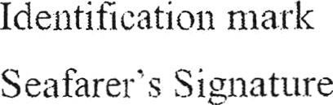

GOVERNMENT OF INDLA


This Continuous Discharge Certificate is issued under Merchant Shipping (Continuous Discharge Certificate) Rules xxxx as amended and is in conformity with the International Labour Organisation Convention No. 108 of 1958.

Signature of issuing autlioiity
Name
Designation


S“eal

Details of certificates

Name of the Certificate | Number | Date and Place of issiie

Details of Voyages

Sr.  No. | Name of Ship, Official No., International Maritime Organisation (IMO) No., Port of Registry, Kw. | Date anal place of Engagement | Date and place of Discharge | Rank of Seafarer | Description of Voyages  Foreign Going/Near Coastal Voyage Indian Coastal | Signature of Master with seal
(1)

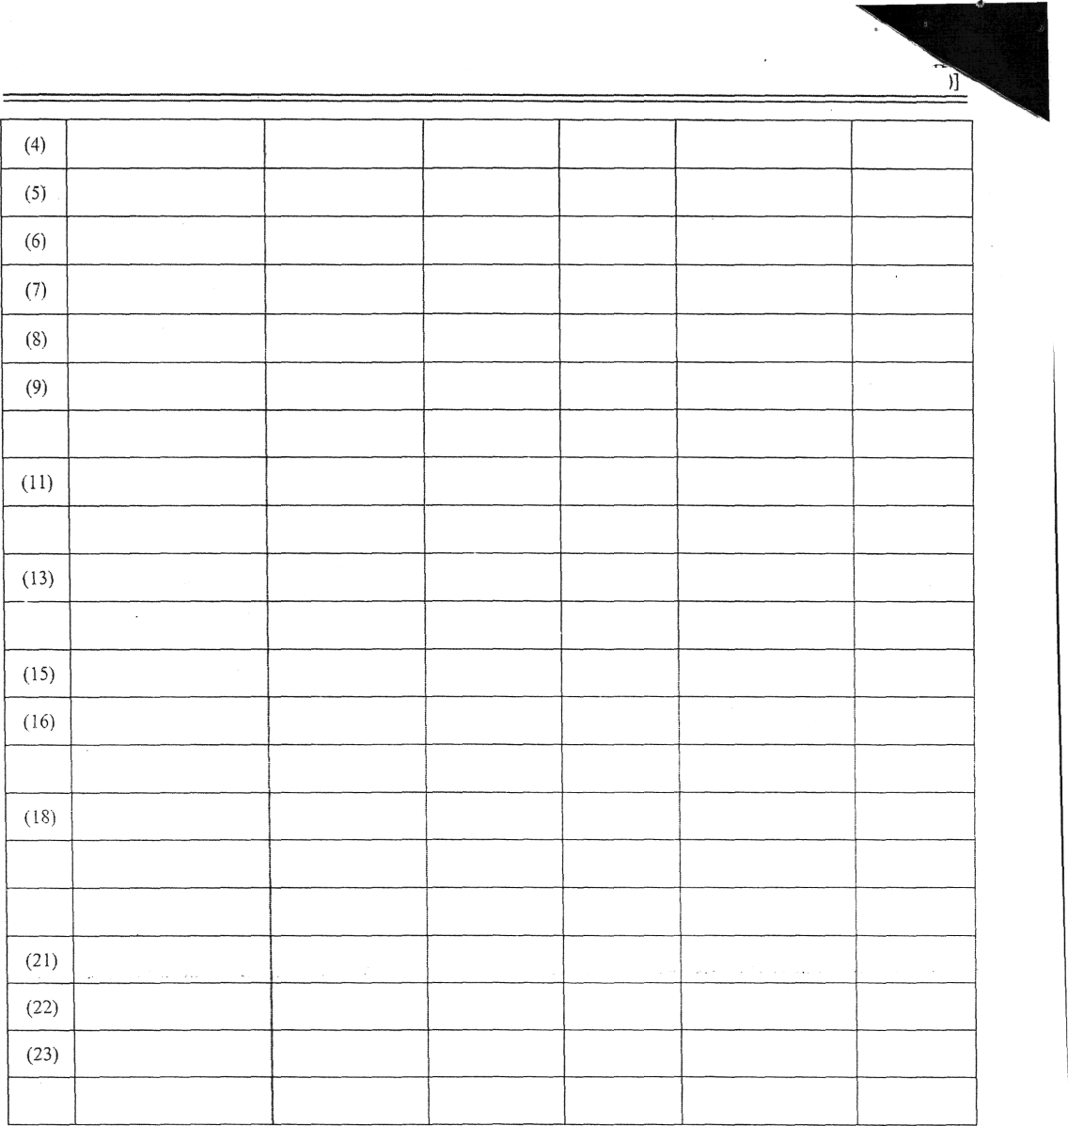

(10)

(12)

(14)

(I 7)

i20)

(24)

Space for Renewal Sticker Space for official Use

PERMANENT ADDRESS OF SEAFARER
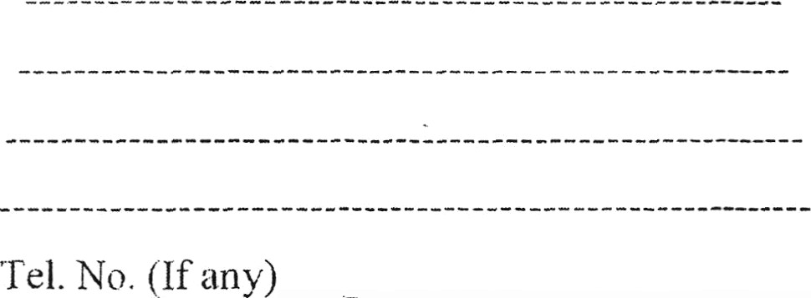
E-mail ( if anv)
. ,

NEXT OF KIN OF SEAFARER
Name Relationship Address

Tel. No. (If any) E-mail (if any)

FORM-3
[See sub- rule 1-4 of rule 12] GOVERNMENT OF INDIA


EMBLEMS

APPLICATION FORM FOR REVALIDATION'DL PLIC/¥TE CONTINUOUS DISCHARGE CERTIFICATE (CDC)
Passport Size (3.5 cm X 3.5
cm) photograph of seafarers

Write the category of CDC —amongst the following to which apply:
- REVALIDATION OF CDC (For CDC Renewal Sticker)
- DUPLICATE CDC (For the case of loss of CDC), (For the CDC which are tom/mutilated /defaced /pages exhausted)
  - Name of the Candidate (as entered in CDC) Details of CDC: CDC No.
Shipping Master Office: Date of issue:
INDOS No. Date:

  - FIR No: Dated:
Name of Police Station: Distt: (Only for duplicate CDC in case of loss of original CDC)

  - Address to receive CDC by POST:
House No.
Steet
Vi1lage/Post office/Tehsil District: State: PIN Code:
Phone No. with STD Code: E-mail Addressed: Mobile to. Nearest Police Station
,,:

State:

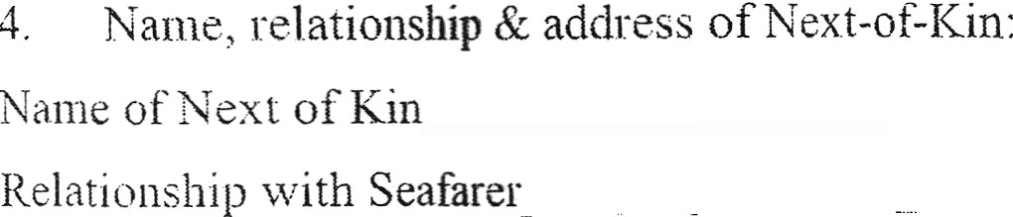
House No
Street:
Village/ Post office/ Tehsil District
State  Phone No. with STD Code
Mobile No. Nearest Police Station

.5. Details of basic familiarisation courses.
Personal Survival Techniques (PST) or Proficiency in survival craft and rescue Boards (PSCRB), Fire Prevention and Fire Fighting (FPFF), Advance Fire Fighting (AFF), Elementary First Aid (EFA) or- Medical First Aid (FIFA) or Medical Case (MC), Personal Safety and Social Responsibilities (PSSR), Security Training for Seafarers with Designated Security Duties (STSDSD) or Ship Security Offices.
Name of Institute:
P.S.T./ P.S.C.R.B. Cert. No.

Name of Institute

FPFF/AFF Cert. No. Date of issue Name of the Institute EFA/MEA/MC Cert. No. Date of issue
Name of the Institute
PSSR Cert. No. Date of issue
Name of Institute
STSDSD/SSO Certificate No. Date of issue
- Medical fitness certificate by the DGS approved medical examiner: Name of the doctor. DGS approval No. for doctor, Place of issue of medical fitness certificate: Date of issue of medical fitness certificate.:
- Details of fee;
Mode of payment: e-payment Amount
- Declaration.
- I hereby declare that all the statements made in this application are true and complete to the best of my knowledge and belief and nothing has been concealed/ distorted and
- I hereby submit that I am the holder of CDC No. issued from the Office of Shipping Master. and
I hereby submit that I have never been debarred front the concerned Shipping master Office and I am aware that, if at any time, I am found to have concealed distorted any material information and the Shipping Master has reasons to believe that I have obtained the CDC by presenting false or erroneous information, my CDC will be cancelled/suspended forthwith as per the provisions contained in Rule 9 of the Merchant Shipping (Continuous Discharge Certificate) Rules, xxxx, as amended.

Place:

Date:
Signature of the applicant

Name of the Applicant

SPEC SIGNATURE. OF THE APPLICANT (Only in case of Duplicate/Replacement CDC)

(Signatories are to be combined to each of the boxes)



List of enclosures:

FOCI-4
(See rule- 14)
Return in respect of Continuous Discharge Certificate issued to seamen during the quarter ending. . .. . . ..... .. ... at the post of ..........
No. of fresh Continuous Discharge Certificate

No. of Duplicate Continuous Discharge Certificate””””””“““°””” ”°"”” ”“““° Issued. . . . . . ........... . .. . . . . . . . . . . ..
No. of Renewal Continuous Discharge Certificate Issued. . . . . ............ ... . .. .. . . . . . .. ...... ...... ... .. . ...
No . of Replacement Continuous Discharge Certificate Issued. . . . . . ........... ... . . . . . . . . . . .. ..

To,
The Director General of Shipping. Mumbai.
SHIPPING MASTER

[F. No. L- 11020/2/20 16-MA]
M. M. HASIJA, Adviser.

